Name_________________________________________________________Date__________

Cultural Project Plan

1. What is the goal of your cultural project? In other words, what do you plan to create to represent your culture?
2. How will you know if it’s successful?
3. Which concepts that we covered in this unit will you include in your coding?
4. What other concepts might you need to know in order to create your project?
5. Find some ideas and either draw them below or use images from an Internet search and paste them here.

**Sketch:** Sketch at least 3 ideas in the boxes on the left, and answer the questions on the right.

| **This image describes:** | **How does it represent your culture?** |
| --- | --- |
| **This image describes:** | **How does it represent your culture?** |
| **This image describes:** | **How does it represent your culture?** |

Culture Project Design

Use the P5 graph below to help you plan how you want to plot your shapes on your sketch. Use Pseudocode to help you design your project in steps here. Be sure to use comment style to help you decide what order your shapes will go in. Be as specific as you can.

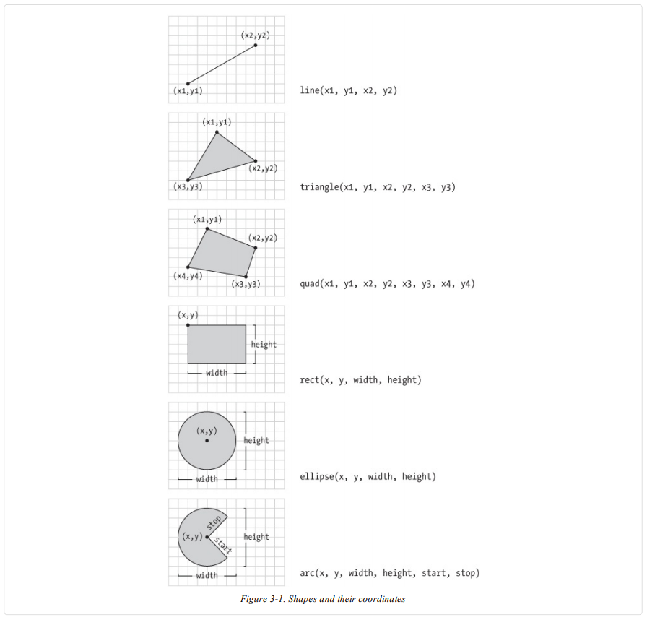

p5.js Shape Function Reference

Use the planning section from your cultural design worksheet to begin coding. For each shape or visual element you try to draw in p5, fill out the table below.

| **Step #** | **What were you trying to do?** | **Did it work?**  **(Y/N)** | **If no, what happened instead?** |
| --- | --- | --- | --- |
|  |  |  |  |
|  |  |  |  |
|  |  |  |  |
|  |  |  |  |
|  |  |  |  |
|  |  |  |  |
|  |  |  |  |
|  |  |  |  |
|  |  |  |  |
|  |  |  |  |
|  |  |  |  |

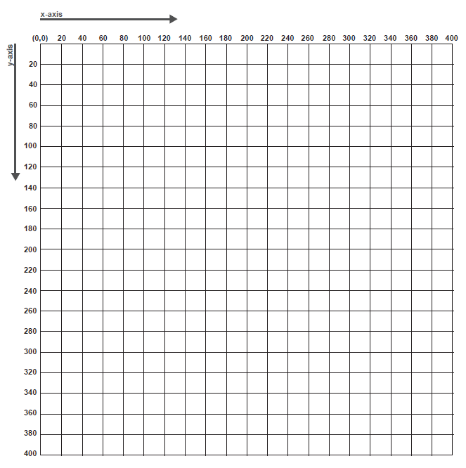

Self Reflection

1. Does the design meet the criteria in the rubric? Explain.

2. What do you like about the design? Name the parts that are successful:

3. What parts of the design are unclear or visually confusing?

4. If your design doesn’t meet the criteria in the rubric, what do you need to add? If it does meet the criteria, what can be changed to improve the design?

**Improve**

List what you need to change to meet the rubric’s criteria. If you have met the criteria, choose 1 - 3 design aspects to improve:

P5 Culture Project Directions

For this project we are creating something in P5 with the shapes we learned that tells about our cultural background. You can do some searching for ideas but some ideas can include a flag of your country, a religious symbol, a favorite place you like to visit that you can create with the shapes, food, etc. The choice is yours. You will also use color to fill in the shapes with corresponding shapes.

Once you have your Sketch finished, you will then be designing a page with HTML and CSS in the same program. The reason for this is that it will be like a web page that showcases your cultural symbol. You will need to include 3 paragraphs with one containing a list of at least three things. It can be an ordered list or an unordered list. You also need to include at least two separate headings using h1 - h6 - any two of them. You need to use a break between the paragraphs and use the p for paragraph. You will also need to use a web link to a resource that tells about your cultural background and lastly you will use an image that represents the design that you created in your sketch.

The following tags will be needed. You may use more if you want to use a cheat sheet.

<h1></h1> - <h6></h6> - for headings

<p></p> - for paragraphs

<ul></ul> - for unordered lists

<li></li> - need for each list item

<ol></ol> - ordered list

<li></li> - need for each list item

<br> break between lines - no closing tag needed

<img src=” “> either a link to an image must be .jpg .jpeg, .png, .gif - no closing tag needed

<a href = “URL-web link”>Name to click on</a>for example need a word in the middle to make the clickable link.

<a href=”<http://google.com>>Google</a>

Once you have created the text and have formatted it with the HTML, you will then use the style.css page to create some additional decoration to your page. I want you to use background color, text size, text color, border on images, etc.

Some examples:

h1 {

color: blue;

}

h2 {

Text-align: right;

color: red;

}

*{background-color: antiquewhite;

}

img {

float: left;

width: 250px;

margin: 10px;

border-color: saddlebrown;

border-width:4px;

border-style: solid;

border-radius: 10px;

}

And you can use class or div which would work for only a small section, image, or line of text

YOu may also use a CSS Cheatsheet to help you.

You may also use code.org and lesson 9 and 11 help you with images and CSS.

**Peer Feedback**

| **Name** | **What do you really like about the project?** |
| --- | --- |
|  |  |
|  |  |
|  |  |

| **Name** | **What would you improve? Give a suggestion.** |
| --- | --- |
|  |  |
|  |  |
|  |  |

| **Name** | **What is one question you have about the project?** |
| --- | --- |
|  |  |
|  |  |
|  |  |

Self-Reflection

1. What were the most successful parts of your project? Review the **Peer Feedback** sheet to help you answer.

2. What parts of your project could be improved? Review the **Peer Feedback** sheet to help you answer.

3. When did you get stuck? What strategies did you use to get unstuck?

4. What is one thing you learned that you didn’t know before you began this project?